**Project 1 LED Blink**

**1.Description**

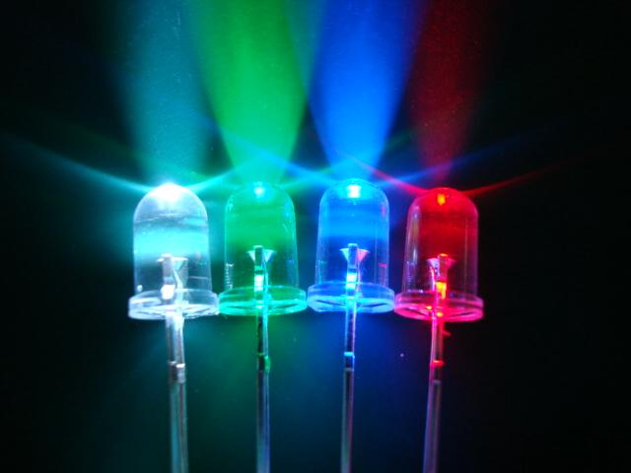For starters and enthusiasts, LED Blink is a fundamental program. LED, the abbreviation of light emitting diodes, consists of Ga, As, P, N chemical compounds and so on.

The LED can flash in diverse color by altering the delay time in the test code. When in control, power on GND and VCC, the LED will be on if S end is in high level, otherwise it will go off.

**2.Specification**

* 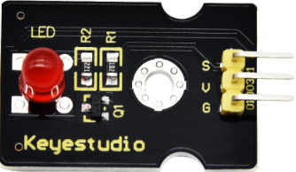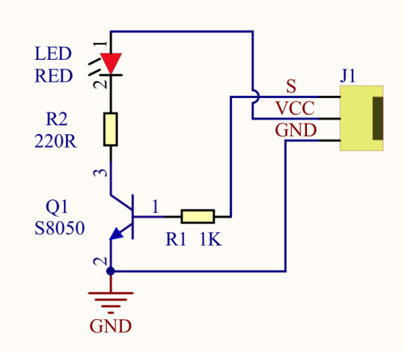Control interface: digital port
* Working voltage: DC 3.3-5V
* Pin spacing: 2.54mm
* LED display color: red

**3.Components**

|  |  |  |
| --- | --- | --- |
| Keyestudio 4.0 Development Board *1 | Keyestudio 8833 Motor Driver Expansion Board *1 | Red LED Module*1 |
|  | 2(1)(1) |  |
| 3P F-F Dupont Wire*1 | USB Cable*1 |  |
|  |  |  |

**4.Wiring Diagram**

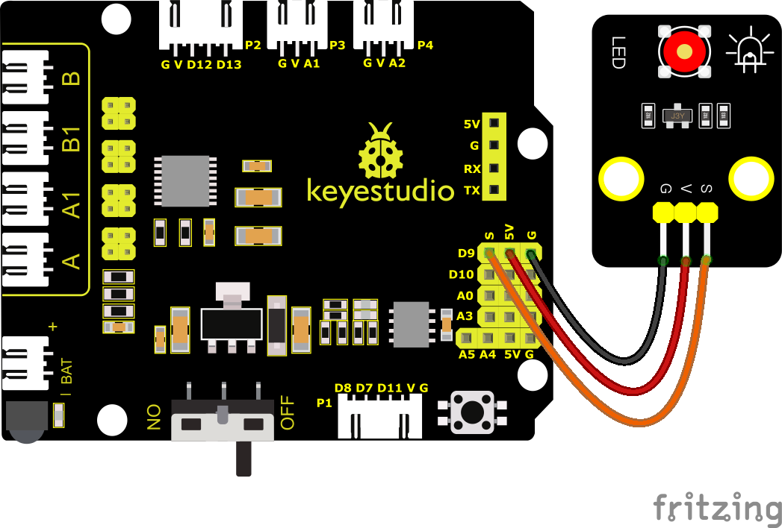

As can be seen from the above figure, the Keyestudio 8833 motor driver expansion board is stacked on the Keyestudio 4.0 development board.

The pin G, V and S of the LED module are connected to G, 5V and D9 of the expansion board respectively.

**5.Test Code**

You can drag blocks to edit. Blocks listed below are for your reference

1. 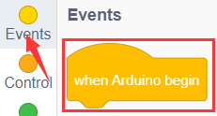
2. 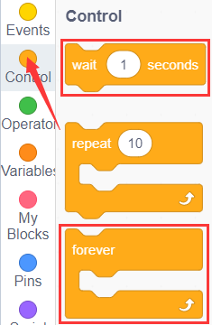
3. 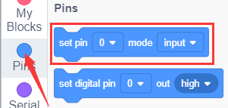
4. 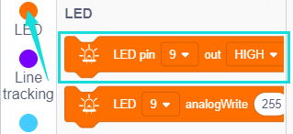

Complete Test Code

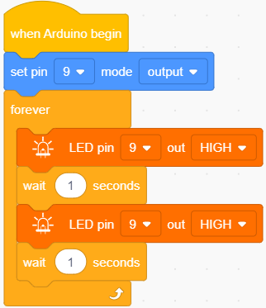

**6.Test Result**

After successfully uploading the code to the V4.0 board, connect the wirings according to the wiring diagram, and use a USB cable to connect the computer to power the board. After powering on, you will see the LED connected to the D9 will be on and off.

**7.Extension Practice**

Next, we look to change the frequency of LED flicker by changing the wait time

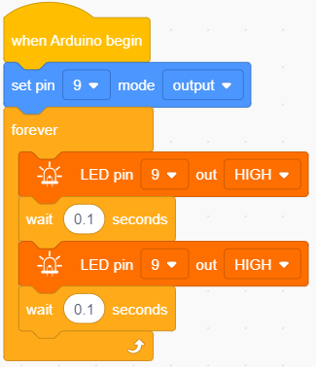

After successfully uploading the code to the V4.0 board, connect the wirings according to the wiring diagram, and use a USB cable to connect the computer to power the board. The test result shows that the LED flashes faster.